What is RHEV Red Hat Enterprise Virtualization Part-1

BY [ARK](https://arkit.co.in/author/admin/) · JUNE 30, 2017

Virtualization is an technology using that we can create N number of Virtual Machines top of base machine. Instead of buying multiple servers for multiple applications (each one for application) where application can’t use entire hardware, resource being wasted. Using virtualization share single hardware resource to multiple applications (virtual machines) increase business. Now what is RHEV .? Red Hat Enterprise Virtualization.

Advantages of RHEV

* Cost Saving (By Utilizing hardware resource effectively)
* Data Center Space saving
* Power Usage saving
* Extend the life of installed applications
* Less Maintenance

RHEV = Red Hat Enterprise Virtualization.

What is RHEV

RHEV (Red Hat Enterprise Virtualization) is management software that integrates and manages multiple KVM virtualization hosts and virtual machines. Integrating and managing dozens of virtualization hosts and hundreds of virtual machines with RHEV.

Difference between standalone KVM and Red Hat Enterprise Virtualization

Management of standalone KVM is done using command line virsh and GUI virt – manager. I think that virt – manager is a reference implementation of a library named libvirt, that is to say that it is for testing library functions. The virt – manager that I use every day also can recognize multiple hypervisors at once, but I do not do anything like common resource management or integrated management of UUIDs for various resources. Out of several virtual machines, it is a very useful tool, but it’s very small-scale. When the number of virtual machines exceeds 50 units, the list display of virtual machines is also dangerous

Virtual machine management function

KVM does not have HA functions (virtual machine level high availability implementation) common in virtualization management software, load balancing function of resources across multiple hypervisors, and so on. Such high value added functions are implemented in RHEV which is integrated virtualization management software. By using RHEV, you can also use live migration, HA function, snapshot function linked with storage function and DR function of virtual environment (disaster countermeasure). In addition, the authentication / authorization mechanism such as the right to use the virtual machine can also operate with the authorization mapped to the organization by linking with the external authentication infrastructure such as Active Directory, Red Hat Directory Server and so on.

It is also effective for hardware replacement to RHEL 7 compatible servers. It is also possible to move virtual machines running on the RHEL Hypervisor based on RHEL 6 to the RHEV Hypervisor based on RHEL 7 online by live migration function.

DR (Disaster Recovery) support for storage domain

Previously, in the event that the database of RHEV-M was totally lost, or from the RHEV-M of a different site due to disaster measures, restore the virtual machine using the contents of the storage domain containing the actual data of the virtual machine That did not support it. Even in previous versions, I could build a DR configuration in the RHEV environment, but I also had to synchronize the RHEV-M database with the remote. In this RHEV 4.1, recovery of virtual machines from the storage domain is supported, and flexibility of the system repair method improves in case of emergency. However, please do not forget to back up the RHEV-M database.

**Conclusion**

With RHEV it is possible to efficiently manage KVM based virtualization resources. If you are considering replacing the virtual environment you are currently using instead of introducing a private cloud, why not consider RHEV as an alternative to OpenStack? RHEV is not the public cloud, OpenStack, RHEV is the best environment to migrate existing applications without cloud support.

Related Articles

[RHEL6 vs RHEL7 Difference](https://arkit.co.in/rhel-6-vs-rhel-7-difference-previous-newer-version/)

[Setting up Linux Lab at Home](https://arkit.co.in/setting-up-linux-lab-creating-and-modifying-vm-network/)

[Download Red Hat Linux KVM Book for Free](https://arkit-in.tradepub.com/free/w_aaaa1831/)

HowTo Install RHEV-M Red Hat Enterprise Virtualization Manager RHEL 7 – Part 2

BY [ARK](https://arkit.co.in/author/admin/) · JULY 2, 2017

We have just published [what is RHEV](https://arkit.co.in/rhev-red-hat-enterprise-virtualization/) is the first article to understand RHEV Better. In order to maintain multiple RHEV-Hosts from central place RHEV-Manager is required. RHEV-M will be used as central place to manage all RHEV-Hosts. In this Article We are going to see HowTo Install RHEV-M Red Hat Enterprise Virtualization Manager RHEL 7.

[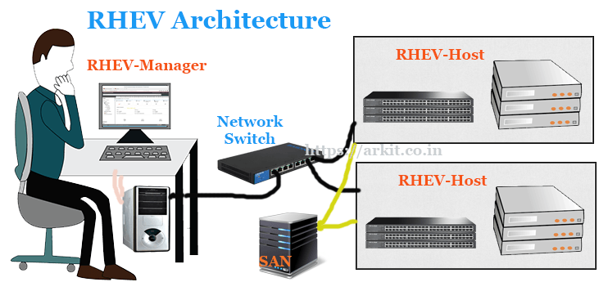](https://i1.wp.com/arkit.co.in/wp-content/uploads/2017/06/RHEV-Architecture.png?ssl=1)

*RHEV Architecture*

Red Hat Enterprise Virtualization Management (RHEV-M) is a virtual management console built on Red Hat Enterprise Linux (RHEL). It interacts with individual RHEV-Hosts using the Virtual Desktop Server Manager (VDSM). A VDSM agent is running on each of the RHEV-H nodes. RHEV-M allows administrators to manage/control number of data centers and their network, compute and storage resources. In addition RHEV-M provides a central repository for storing virtual machines, disks, images and virtual machine snapshots.

Install RHEV-M Hardware Requirements

* Hard Disk Space Minimum 50GB
* RAM Minimum 4GB – Max 2TB
* Dual Core or High Processor
* 1Gbps NIC Card

Software Requirements

* Operating System RHEL 7
* Red Hat Subscription Credentials
* DNS Server IP Details
* DNS PTR Record (for name resolution)
* Client Side (Windows/Linux/Mac) Browser with latest updates

It’s mandatory to register your Linux machine with Red Hat so that you will get an appropriate RHEVM supportable repository. You can also do an offline RHEV-M installation by one time download of repo from Red Hat.

[root@ArkIT-RHEV ~]# subscription-manager register

Registering to: subscription.rhsm.redhat.com:443/subscription

Username: raviankam

Password:

The system has been registered with ID: 1234567890hj-1872hskhr-y634knasdfg

[root@ArkIT-RHEV ~]# subscription-manager attach --auto

After completion subcription successfully just list all available repositories and enble appropriate then run RHEV-M Installation

HowTo Install RHEV-M Red Hat Enterprise Virtualization Manager RHEL 7

# subscription-manager list --available

[root@ArkIT-RHEV ~]# subscription-manager list --available | grep Virtualization

Subscription Name: 60 Day Self-Supported Red Hat Enterprise Linux with Smart Virtualization and Management Evaluation

Red Hat Virtualization Host

Red Hat Virtualization

# subscription-manager repos --enable=rhel-7-server-rpms

# subscription-manager repos --enable=rhel-7-server-supplementary-rpms

# subscription-manager repos --enable=rhel-7-server-rhv-4.1-rpms

# subscription-manager repos --enable=rhel-7-server-rhv-4-tools-rpms

# subscription-manager repos --enable=jb-eap-7-for-rhel-7-server-rpms

# subscription-manager attach --pool=8a85f9815cd0aad0015cd0add04f03dd

# yum update; yum install rhevm

# engine-setup

Below is an text file of yum update command output

[yum update; yum install rhevm – output](https://arkit.co.in/wp-content/uploads/2017/07/yum-update-output.txt)

[](https://i2.wp.com/arkit.co.in/wp-content/uploads/2017/07/1.jpg?ssl=1)

*engine-setup command output*

First set of questions it asks you about Product Options, you have to answer them

[](https://i0.wp.com/arkit.co.in/wp-content/uploads/2017/07/2.jpg?ssl=1)

*Product Options RHEV-M Setup*

--== PRODUCT OPTIONS ==--

Configure Engine on this host (Yes, No) [Yes]:

Configure Image I/O Proxy on this host? (Yes, No) [Yes]:

Configure WebSocket Proxy on this host (Yes, No) [Yes]:

Please note: Data Warehouse is required for the engine. If you choose to not configure it on this host, you have to configure it on a remote host, nd then configure the engine on this host so that it can access the database of the remote Data Warehouse host.

Configure Data Warehouse on this host (Yes, No) [Yes]:

Configure VM Console Proxy on this host (Yes, No) [Yes]:

[](https://i1.wp.com/arkit.co.in/wp-content/uploads/2017/07/3.jpg?ssl=1)

*Packages Options*

--== NETWORK CONFIGURATION ==--

Host fully qualified DNS name of this server [localhost.localdomain]:

[WARNING] Failed to resolve localhost.localdomain using DNS, it can be resolved only locally

Setup can automatically configure the firewall on this system.

Note: automatic configuration of the firewall may overwrite current settings.

Do you want Setup to configure the firewall? (Yes, No) [Yes]:

[ INFO ] firewalld will be configured as firewall manager.

[](https://i0.wp.com/arkit.co.in/wp-content/uploads/2017/07/4.jpg?ssl=1)

*Network Configuration*

--== DATABASE CONFIGURATION ==--

Where is the DWH database located? (Local, Remote) [Local]:

Setup can configure the local postgresql server automatically for the DWH to run. This may conflict with existing applications.

Would you like Setup to automatically configure postgresql and create DWH database, or prefer to perform that manually? (Automatic, Manual) [Automaic]:

Where is the Engine database located? (Local, Remote) [Local]:

Setup can configure the local postgresql server automatically for the engine to run. This may conflict with existing applications.

Would you like Setup to automatically configure postgresql and create Engine database, or prefer to perform that manually? (Automatic, Manual) [Autmatic]:

Select the Database whether it is local database or remote Database if it is remote provide remote server details

--== OVIRT ENGINE CONFIGURATION ==--

Engine admin password:

Confirm engine admin password:

[WARNING] Password is weak: it is too simplistic/systematic

Use weak password? (Yes, No) [No]: yes

Application mode (Virt, Gluster, Both) [Both]:

Engine Password is the main password while connecting admin portal you have to provide

--== STORAGE CONFIGURATION ==--

Default SAN wipe after delete (Yes, No) [No]: yes

SAN Configuration do want wipe entire default space

--== PKI CONFIGURATION ==--

Organization name for certificate [localdomain]:

Public Key Infrastructure Certificate for provided domain, while accessing admin portal if domain name does not match you can’t load admin portal

--== APACHE CONFIGURATION ==--

Setup can configure the default page of the web server to present the application home page. This may conflict with existing applications.

Do you wish to set the application as the default page of the web server? (Yes, No) [Yes]:

Setup can configure apache to use SSL using a certificate issued from the internal CA.

Do you wish Setup to configure that, or prefer to perform that manually? (Automatic, Manual) [Automatic]:

 Configure RHEV-M Configuration with SSL for accessing using https://adminportalURL:8443

[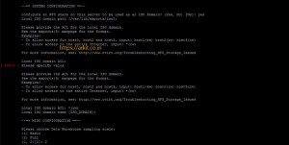](https://i1.wp.com/arkit.co.in/wp-content/uploads/2017/07/10.jpg?ssl=1)

*RHEV-M System Configuration*

Verify Final configuration settings and say OK so that RHEV-M will start installing

[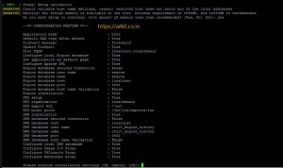](https://i0.wp.com/arkit.co.in/wp-content/uploads/2017/07/11.jpg?ssl=1)

*Final Verification for RHEV-M Installation and Configuration*

Summary if installation finally RHEV-M Installed successfully

[](https://i1.wp.com/arkit.co.in/wp-content/uploads/2017/07/12.jpg?ssl=1)

*Installation Summary*

Now Access RHEV-M Admin portal using URL to manage everything from single place

https://localhost.localdomain.ovirt-engine/sso/login.html

[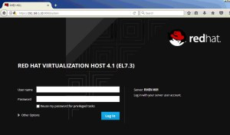](https://i2.wp.com/arkit.co.in/wp-content/uploads/2017/07/RHEV-H1.jpg?ssl=1)

*RHEV-M Admin portal Login screen*

After Successful Login you will as like below

[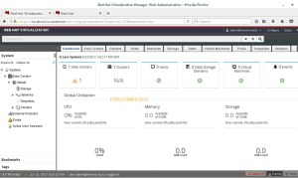](https://i2.wp.com/arkit.co.in/wp-content/uploads/2017/07/14.jpg?ssl=1)

*HowTo Install RHEV-M Red Hat Enterprise Virtualization Manager RHEL 7 – Part 2*

That’s it about HowTo Install RHEV-M Red Hat Enterprise Virtualization Manager 4.1

Related Articles

[What is RHEV Part-1](https://arkit.co.in/rhev-red-hat-enterprise-virtualization/)

[Kernel-Based Virtual Machine installation Step by Step Guide RHEL 7](https://arkit.co.in/howto-install-kvm-hypervisor-rhel-7/)

[Semanage Command not Found](https://arkit.co.in/semanage-command-not-found/)

RHEV Hypervisor Installation Step by Step Guide Part-3

BY [ARK](https://arkit.co.in/author/admin/) · JULY 8, 2017

This before we posted an post about [RHEV-M (Red Hat Enterprise Virtualization Manager)](https://arkit.co.in/howto-install-rhev-m-red-hat-enterprise-virtualization-manager/) Here is an Continuation post for Installing Red Hat Enterprise Hypervisor Host. Manager is used to manage multiple RHEVH (Red Hat Hyperisor Hosts). In this article we are going to see HowTo Install RHEV Hypervisor Installation Step by Step Guide.

Hypervisor we can also install in RHEL versions but installing direct ISO will give to optimized environment and less performance issues. Hypervisor Operating System is fully optimized and runs only required services.

[What is RHEV – Part-1](https://arkit.co.in/rhev-red-hat-enterprise-virtualization/)

[HowTo Install RHEV Manager – Part-2](https://arkit.co.in/howto-install-rhev-m-red-hat-enterprise-virtualization-manager/)

[Download RHEV-H Link](https://access.redhat.com/products/red-hat-virtualization#getstarted)

[AdChoices](https://www.google.com/url?ct=abg&q=https://www.google.com/adsense/support/bin/request.py%3Fcontact%3Dabg_afc%26url%3Dhttps://arkit.co.in/rhev-hypervisor-installation/%26gl%3DUS%26hl%3Den%26client%3Dca-pub-3797659217082577%26ai0%3D&usg=AFQjCNEILrlxDNUapK5HD9431HgYwPKIMA)

[Windows 7 Installation](https://googleads.g.doubleclick.net/pagead/ads?client=ca-pub-3797659217082577&output=html&h=15&w=728&bih=722&biw=1058&slotname=6582066648&adk=2829033451&url=https://arkit.co.in/rhev-hypervisor-installation/&ref=https://www.linkedin.com/&eid=137237720&u_his=2&brdim=183,74,183,74,1920,23,1073,806,1073,722&prev_fmts=728x15_0ads_al&format=fpkc_al_lp&kw_type=radlink&hl=en&rt=ChBZY7ODAAvoXAo_HAUbCw35EgEgGghv71fYvvFSIigBUhMInYysj5n_1AIVEJcBCh0-dwfoeAGCARoKFldpbmRvd3MgNyBJbnN0YWxsYXRpb24SAIIBFgoSTGludXggSW5zdGFsbGF0aW9uEgCCARkKFUluc3RhbGxhdGlvbiBEb3dubG9hZBIAiAEA&ad_type=text)

[Linux Installation](https://googleads.g.doubleclick.net/pagead/ads?client=ca-pub-3797659217082577&output=html&h=15&w=728&bih=722&biw=1058&slotname=6582066648&adk=2829033451&url=https://arkit.co.in/rhev-hypervisor-installation/&ref=https://www.linkedin.com/&eid=137237720&u_his=2&brdim=183,74,183,74,1920,23,1073,806,1073,722&prev_fmts=728x15_0ads_al&format=fpkc_al_lp&kw_type=radlink&hl=en&rt=ChBZY7ODAAvoXAo_HAUbCw35EgEgGghv71fYvvFSIigBUhMInYysj5n_1AIVEJcBCh0-dwfoeAGCARoKFldpbmRvd3MgNyBJbnN0YWxsYXRpb24SAIIBFgoSTGludXggSW5zdGFsbGF0aW9uEgCCARkKFUluc3RhbGxhdGlvbiBEb3dubG9hZBIAiAEB&ad_type=text)

[Installation Download](https://googleads.g.doubleclick.net/pagead/ads?client=ca-pub-3797659217082577&output=html&h=15&w=728&bih=722&biw=1058&slotname=6582066648&adk=2829033451&url=https://arkit.co.in/rhev-hypervisor-installation/&ref=https://www.linkedin.com/&eid=137237720&u_his=2&brdim=183,74,183,74,1920,23,1073,806,1073,722&prev_fmts=728x15_0ads_al&format=fpkc_al_lp&kw_type=radlink&hl=en&rt=ChBZY7ODAAvoXAo_HAUbCw35EgEgGghv71fYvvFSIigBUhMInYysj5n_1AIVEJcBCh0-dwfoeAGCARoKFldpbmRvd3MgNyBJbnN0YWxsYXRpb24SAIIBFgoSTGludXggSW5zdGFsbGF0aW9uEgCCARkKFUluc3RhbGxhdGlvbiBEb3dubG9hZBIAiAEC&ad_type=text)

RHEV Hypervisor Installation

After successful completion of download ISO file. Please write to CD/DVD and try to load and boot from CD/DVD

[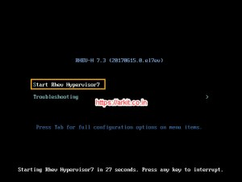](https://i1.wp.com/arkit.co.in/wp-content/uploads/2017/07/16.jpg?ssl=1)

*Start RHEV Hypervisor 7*

Select installation Start Rhev Hypervisor 7

[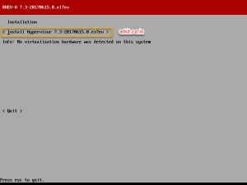](https://i2.wp.com/arkit.co.in/wp-content/uploads/2017/07/Install-Hypervisor-7.3.jpg?ssl=1)

*Install Hypervisor 7.3*

To Continue Installation you have to select “Install Hypervisor 7.3“

[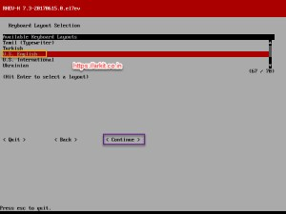](https://i0.wp.com/arkit.co.in/wp-content/uploads/2017/07/KeyBoard-Layout-Selection.jpg?ssl=1)

*KeyBoard Layout Selection*

RHEV Hypervisor Installation Select “Key Board Language” and Hit **Continue**

[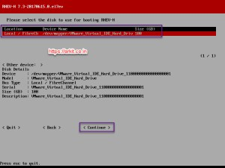](https://i2.wp.com/arkit.co.in/wp-content/uploads/2017/07/Select-Disk-for-Booting.jpg?ssl=1)

*Select Disk for Booting*

Please Select the Disk to use for Booting RHEV-H then Click **Continue**

[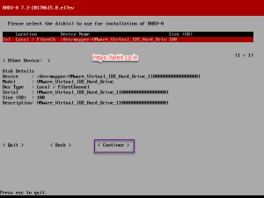](https://i0.wp.com/arkit.co.in/wp-content/uploads/2017/07/Disks-for-Installation.jpg?ssl=1)

*Disks for Installation*

Storage Volumes and there space allocation

* Swap MB : 7960
* Config MB: 5
* Logging MB: 2048
* Data MB: 83531

[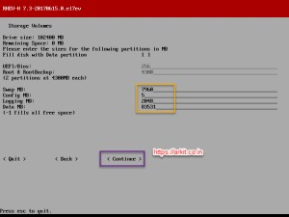](https://i0.wp.com/arkit.co.in/wp-content/uploads/2017/07/Storage-Volumes.jpg?ssl=1)

*Storage Volumes*

After partitioning please **continue**

[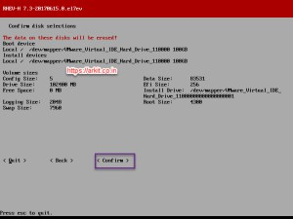](https://i1.wp.com/arkit.co.in/wp-content/uploads/2017/07/Confirm-Disk-Selection.jpg?ssl=1)

*Confirm Disk Selection*

The Data on these Disks will we erased! – Click **Confirm**

[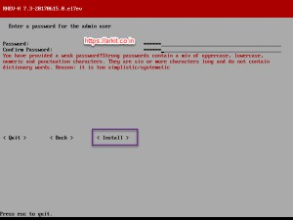](https://i0.wp.com/arkit.co.in/wp-content/uploads/2017/07/Set-root-user-password.jpg?ssl=1)

*Set root user password*

Enter a password for the admin user and confirm password – Click **Install**

[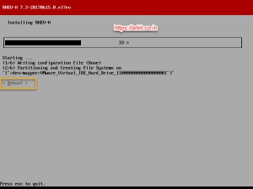](https://i2.wp.com/arkit.co.in/wp-content/uploads/2017/07/Installation-is-in-Progress.jpg?ssl=1)

*Installation is in Progress*

Installation of RHEV Hypervisor is in progress

[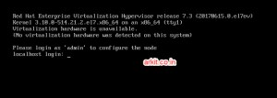](https://i1.wp.com/arkit.co.in/wp-content/uploads/2017/07/Login-Screen.jpg?ssl=1)

*Login Screen*

[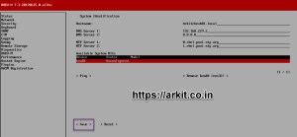](https://i1.wp.com/arkit.co.in/wp-content/uploads/2017/07/bond0-Unconfigured.jpg?ssl=1)

*bond0 Unconfigured*

Configure bonding you have to select bond0 and click **Enter**

[](https://i0.wp.com/arkit.co.in/wp-content/uploads/2017/07/bond0-configuration.jpg?ssl=1)

*bond0 configuration*

Select Boot protocol Static

* IP Address :
* Netmask :
* Gateway :

[AdChoices](https://www.google.com/url?ct=abg&q=https://www.google.com/adsense/support/bin/request.py%3Fcontact%3Dabg_afc%26url%3Dhttps://arkit.co.in/rhev-hypervisor-installation/%26gl%3DUS%26hl%3Den%26client%3Dca-pub-3797659217082577%26ai0%3D&usg=AFQjCNEILrlxDNUapK5HD9431HgYwPKIMA)

[Visor Windows](https://googleads.g.doubleclick.net/pagead/ads?client=ca-pub-3797659217082577&output=html&h=90&w=160&bih=722&biw=1058&slotname=3706943449&adk=2442574747&url=https://arkit.co.in/rhev-hypervisor-installation/&ref=https://www.linkedin.com/&eid=137237720&u_his=2&brdim=183,74,183,74,1920,23,1073,806,1073,722&prev_fmts=160x90_0ads_al&format=fpkc_al_lp&kw_type=radlink&hl=en&rt=ChBZY7ODAAvUoQo_BwJ4BWL3EgEgGgjia0zESq2VbCgBUhMI7I6sj5n_1AIVgxg_Ch0nqwBkeAGCAREKDVZpc29yIFdpbmRvd3MSAIIBEwoPR28gSW5zdGFsbGF0aW9uEgCCAQ4KCkh5cGVydmlzb3ISAIgBAA&ad_type=text)

[Go Installation](https://googleads.g.doubleclick.net/pagead/ads?client=ca-pub-3797659217082577&output=html&h=90&w=160&bih=722&biw=1058&slotname=3706943449&adk=2442574747&url=https://arkit.co.in/rhev-hypervisor-installation/&ref=https://www.linkedin.com/&eid=137237720&u_his=2&brdim=183,74,183,74,1920,23,1073,806,1073,722&prev_fmts=160x90_0ads_al&format=fpkc_al_lp&kw_type=radlink&hl=en&rt=ChBZY7ODAAvUoQo_BwJ4BWL3EgEgGgjia0zESq2VbCgBUhMI7I6sj5n_1AIVgxg_Ch0nqwBkeAGCAREKDVZpc29yIFdpbmRvd3MSAIIBEwoPR28gSW5zdGFsbGF0aW9uEgCCAQ4KCkh5cGVydmlzb3ISAIgBAQ&ad_type=text)

Click **Save**

[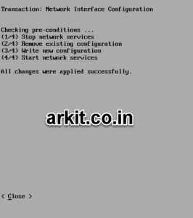](https://i0.wp.com/arkit.co.in/wp-content/uploads/2017/07/bond-completed.jpg?ssl=1)

*bond completed*

Adding RHEV Hypervisor to RHEV Manager

Ping to the RHEV-M Host and check your able to reach

[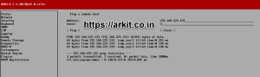](https://i2.wp.com/arkit.co.in/wp-content/uploads/2017/07/ping-from-rhevh-to-rhevm.jpg?ssl=1)

*ping from rhevh to rhevm*

If it is reachable then your almost near by

[](https://i0.wp.com/arkit.co.in/wp-content/uploads/2017/07/enable-remote-ssh-access-from-security.jpg?ssl=1)

*enable remote ssh access from security*

Go to Security Tab and Enable SSH Remote Access which is used to authenticate from RHEVM for adding and changing Host settings from Manager

After enabling the SSH provide password and Hit Save

If you have requirement to monitor RHEV-H from monitoring tool enable SNMP

[](https://i0.wp.com/arkit.co.in/wp-content/uploads/2017/07/Enable-SNMP.jpg?ssl=1)

*Enable SNMP*

The Final step is to add Host to Manager to do that add RHEV-M details by selecting RHEV-M Tab

[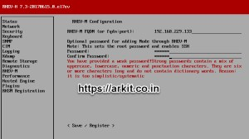](https://i2.wp.com/arkit.co.in/wp-content/uploads/2017/07/RHEV-M-Configuration.jpg?ssl=1)

*RHEV-M Configuration*

RHEV-M FQDN – Provide Fully Qualified Domain Name OR IP Address of Manager

Provide Password for root

Click **<Save / Register>**

Go Back to Red Hat Enterprise Virtualization Manager and check Host Tab you should see Added Host Pending for approval

[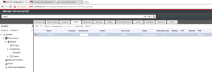](https://i1.wp.com/arkit.co.in/wp-content/uploads/2017/07/Host-is-Pending-for-approval.png?ssl=1)

*Host is Pending for approval*

Select Appropriate Host and Click Approve to continue

[](https://i2.wp.com/arkit.co.in/wp-content/uploads/2017/07/After-adding-Host-to-Manager.png?ssl=1)

*After adding Host to Manager*

That’s it. RHEV Hypervisor installation completed successfully and also added to RHEV-M Now Next step is to Create Virtual Machines, Adding Storage Domains and Manage Virtual machines from Manager